10.1: Outcomes and Events

If you flip a penny, how many possible results are there?

If you flip a penny and a nickel, how many possible results are there?

If you flip two pennies, how many possible results are there?

Simplify the fraction.

1.  2. 3. 

4.  5.  6. 

You spin the spinner shown.

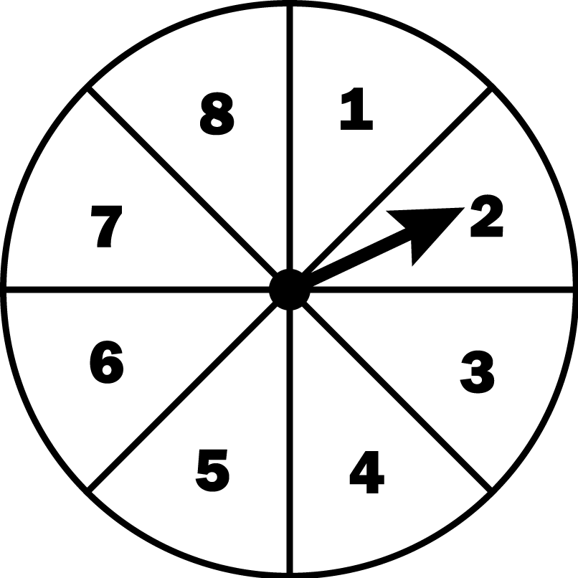

1. How many possible results are there?

2. Of the possible results, in how many ways can you spin an even number? an odd number?

Definitions

Experiment:

Outcomes:

Event:

Favorable Outcomes:

You randomly choose one of the tiles shown below. Find the favorable outcomes of the event.



1. Choosing a 4

1. Choosing an even number
2. Choosing a number less than 2
3. Choosing an odd number greater than 6

5. Choosing a number divisible by 2

1. Choosing a number greater than 10

You randomly choose one shape from the bag.   
(a) Find the number of ways the event can occur.  
(b) Find the favorable outcomes of the event.

1. Choosing a triangle
2. Choosing a star
3. Choosing *not* a square
4. Choosing *not* a circle
5. A beverage cooler contains bottles of orange juice and apple juice. There are 44 bottles in the cooler.

a. You are equally likely to randomly choose a bottle of orange juice or a bottle of apple juice from the cooler. How many of the bottles are apple juice?

b. Two of the bottles of orange juice are replaced with apple juice.   
How many ways can you randomly choose a bottle of apple juice from the cooler?

12. Three girls and four boys made the final round of the spelling bee.

a. How many ways can you randomly choose a girl to be the first contestant?

b. Given that part (a) occurred, how many ways can you randomly choose a girl to be the second contestant?