9.1: Surface Areas of Prisms

How can you determine the amount of cardboard used to make a cereal box?

List at least two different methods.

Evaluate the expression.

1. 

2. 

3. 

4. 

5. 

6. 

How are the concepts of *area* and *surface area* similar? How are they different?

What kind of units are used to measure surface area?

Surface Area of a Prism: The surface area S of any prism is the sum of the areas of the bases and the lateral faces.

S = areas of bases + areas of lateral faces

Lateral Surface Area: the sum of the areas of the lateral faces

Find the surface area of the prism.

1. 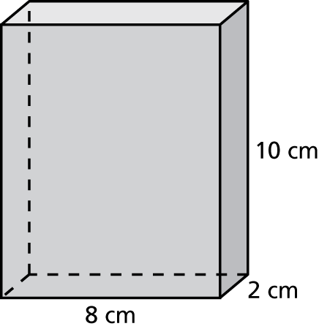 2. 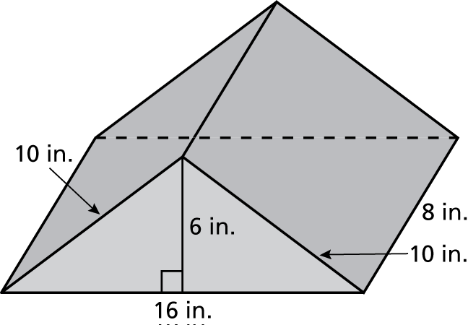

3. 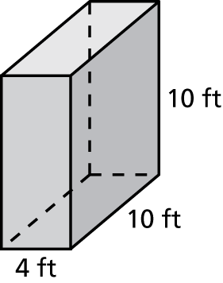 4. 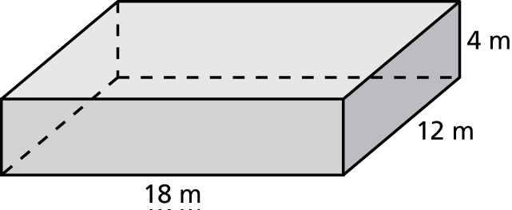

5. 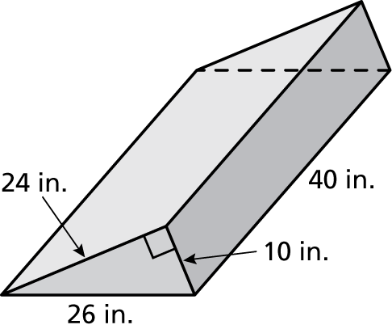 6. 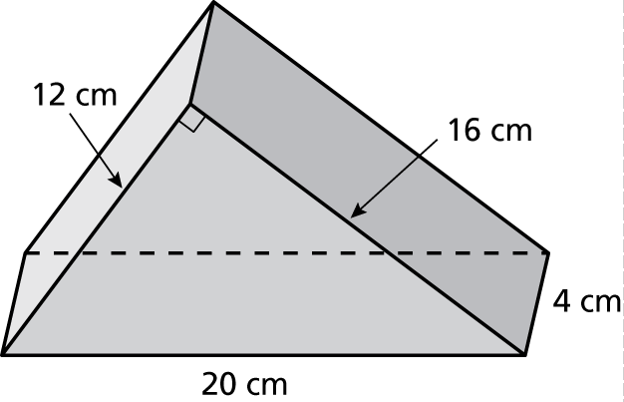

7. The inside of a baking pan is to be lined with tinfoil. The pan is 12 inches long, 9 inches wide, and 1.5 inches tall. How many square inches of tinfoil are needed?

8. Draw and label a rectangular prism that has a surface area of 96 square meters.