**11.5: Similar Figures**

Tell whether the two figures are similar. Explain your reasoning.

1. 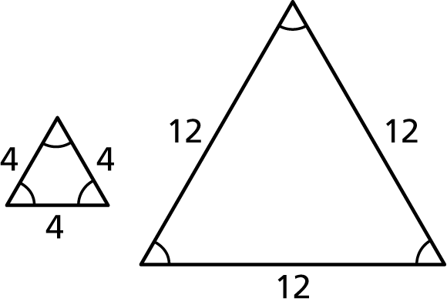 2. 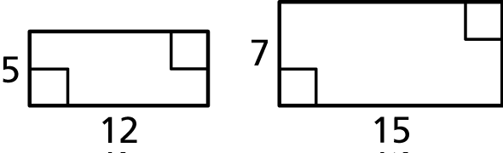

3. 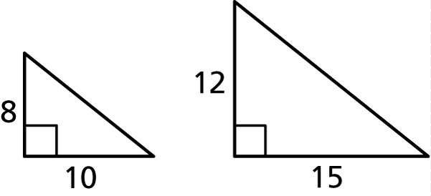 4. 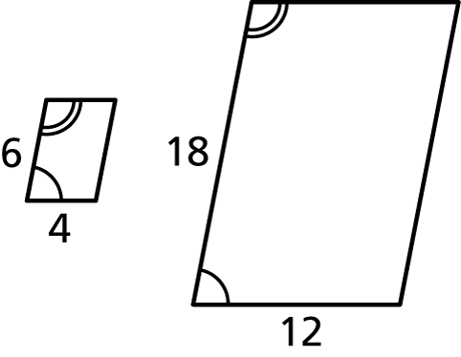

**Similar Figures:** figures that have the same shape but not necessarily the same size

1. Name the corresponding angles and the corresponding sides of the similar figures.

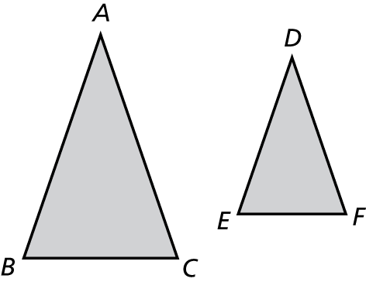

2. Tell whether the two figures are similar. Explain your reasoning.

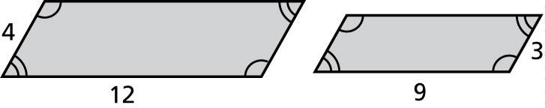

3. The rectangular traffic sign is 18 inches wide and 8 inches tall. The rectangular realtor sign is 27 inches wide and 10 inches tall. Are the signs similar?

4. The given rectangle needs to be modified.

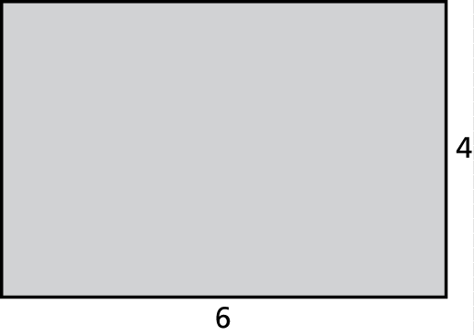

a. Each side length is increased by 2.

Is the new rectangle similar to the original?

b. Each side length is increased by 50%.

Is the new rectangle similar to the original?

5. Which of the following card dimensions are similar rectangles?

2 in. by 5 in. 3 in. by 6 in.

1 in. by 3 in. 1 in. by 2.5 in.