13.2: Slope of a Line

Slope: the rate of change between any two points on a line; the measure of *steepness* of a line

slope = change in y/change in x or the rise/the run

* Draw an example of a line that has a positive slop, a negative slope, a slope of zero, and an undefined slope

Examples:

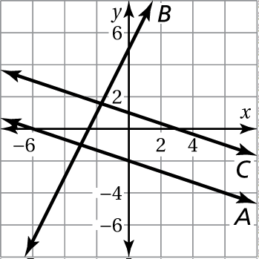 1. Refer to the graph.

a. Which lines have negative slopes?

b. Which line has the steepest slope?

c. Are any two of the lines parallel? Explain.

Draw a line through each point using the given slope. What do you notice about the two lines?

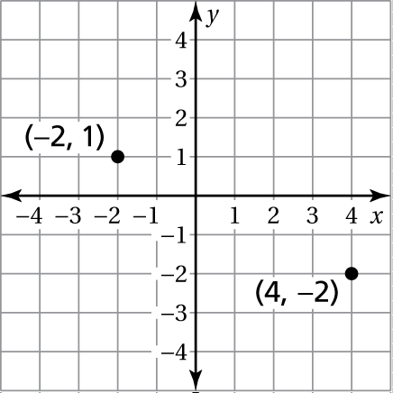 2.  3. 

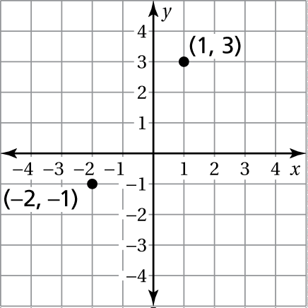

Find the slope of the line.

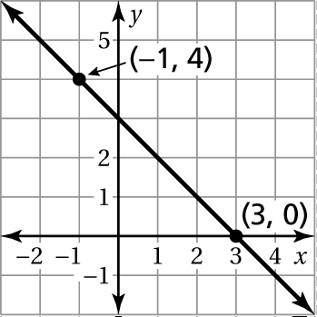 4. 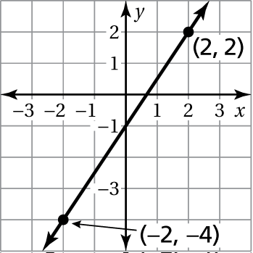 5.

Find the slope of the line through the given points.

6.  7. 

8. An awning covers a window that is 4 feet high. When the awning is opened,   
it extends 2 feet from the base of the window. Find the slope of the awning.

Graph the linear equations    
and  in a coordinate plane.   
What do you notice?

Graph the linear equations   
and  in a coordinate plane.  
What do you notice?

Find the slope of each line.

1. 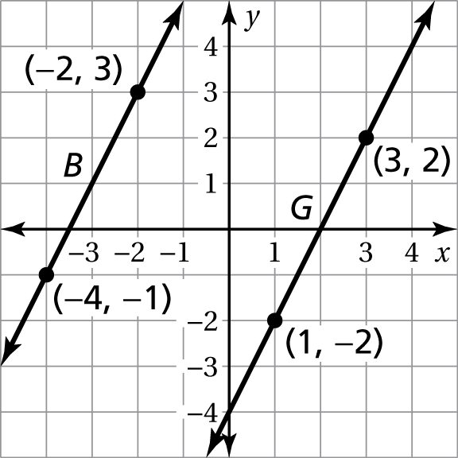 2. 