13.6: Writing Equations in Slope-Intercept Form

1. Write an equation that represents each side of the figure.

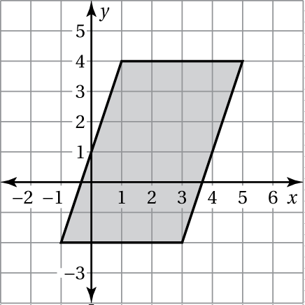

Write an equation of the line in slope-intercept form.

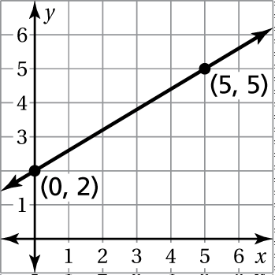

2. 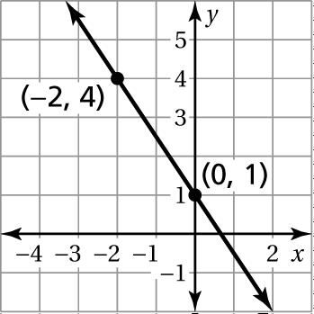 3.

4. A plant is 3 inches tall when you purchase it and grows 2 inches per month. Write an equation that represents the height *y* (in inches) of a plant that you purchased *x* months ago.

Write an equation of the line that passes through the points.

5.  6. 

7. A bucket is empty. You are filling the bucket with water at a rate of   
3 inches per second.

a. Plot the points 

b. What do the points in part (a) represent?

c. Draw a line through the points.

d. What does the line represent?

e. Write an equation of the line.

Matching Equations and Graphs

Copy the equations and graphs onto index cards. Mix the cards up and lay them face down. With a friend, take turns turning over pairs of cards. If you find a matching graph and equation, remove the pair and take another turn. If the pair doesn’t match, turn both cards face down again. Continue until all pairs are removed. The player with the most pairs wins.

