10.5: Independent and Dependent Events

Think about the words independent and dependent. What do they mean?

Give an example of a time in which you were independent. Give an example of a time in which you were dependent.

You randomly choose one marble from a   
bag containing 5 blue marbles, 2 red marbles, 2 green marbles, and 1 purple marble. Find the favorable outcomes of the event.

1. Choosing a blue marble

2. Choosing a red marble

3. Choosing a green marble

4. Choosing a purple marble

5. *Not* choosing a blue marble

6. *Not* choosing a red marble

You have a bag of marbles. You draw a marble, set it aside, and a draw a second marble. Your friend says the events are independent. Is your friend correct? Explain.

Tell whether the events are *independent* or *dependent*. Explain.

1. You roll a number cube twice. The first roll is a 3 and the second roll is an odd number.

2. You flip a coin twice. The first flip is heads and the second flip is tails.

3. You randomly draw a marble from a bag containing 3 red marbles and 5 blue marbles. You keep the marble and then draw a second marble.

4. You randomly draw a marble from a bag containing 6 red marbles and 2 blue marbles. You put the marble back and then draw a second marble.

Independent events: the occurrence of one event *does not* affect the likelihood that the other event(s) will occur

Dependent events: the occurrence of one event *does* affect the likelihood that the other event(s) will occur

Tell whether the events are *independent* or *dependent*. Explain.

1. You spin a spinner twice.

First Spin: You spin a 2. Second Spin: You spin an odd number.

2. Your committee is voting on the leadership team.

First Vote: You vote for a president. Second Vote: You vote for a vice president.

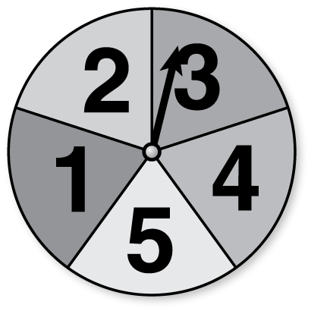

You spin the spinner and flip a coin. Find the   
probability of the compound event.

3. Spinning an odd number and flipping heads

4. *Not* spinning a 5 and flipping tails

You randomly choose one of the tiles. Without replacing the first tile, you choose a second tile. Find the probability of the compound event.



5. Choosing a 6 and then a prime number 6. Choosing two odd numbers

 7. You randomly pull two bills   
from your wallet. What is   
the probability they are   
both $20?

You roll a number cube twice. Find the probability of the compound event.

8. Rolling two numbers whose sum is 2

9. Rolling an even number and then an odd number

|  |  |  |  |  |  |  |  |  |  |
| --- | --- | --- | --- | --- | --- | --- | --- | --- | --- |
| 94 | 90 | 14 | 51 | 40 | 73 | 4 | 33 | 99 | 20 |
| 79 | 95 | 22 | 36 | 0 | 93 | 10 | 0 | 54 | 85 |
| 97 | 27 | 27 | 12 | 5 | 72 | 1 | 42 | 30 | 97 |
| 2 | 83 | 61 | 20 | 98 | 72 | 30 | 24 | 94 | 92 |
| 4 | 11 | 69 | 98 | 63 | 31 | 8 | 99 | 19 | 39 |
| 11 | 24 | 85 | 37 | 59 | 60 | 7 | 1 | 1 | 69 |
| 70 | 88 | 37 | 11 | 45 | 98 | 69 | 54 | 63 | 92 |
| 67 | 79 | 55 | 33 | 21 | 62 | 88 | 12 | 45 | 46 |
| 28 | 81 | 98 | 49 | 40 | 22 | 62 | 61 | 80 | 77 |
| 46 | 92 | 62 | 33 | 45 | 80 | 86 | 25 | 71 | 46 |

On a spinner, there is a 40% chance of spinning green and a 30% chance of spinning red. Design and use a simulation involving 100 randomly generated numbers to find the experimental probability that you will spin green on the first spin and red on the second spin.

1. Use the random number generator on a graphing calculator. Randomly generate 100 numbers from 0 to 99. The table below shows the results.

Let the digits 1 through 4 in the tens place represent green on the first spin and the digits 1 through 3 in the ones place represent red on the second spin. Any number that meets these criteria represents green on the first spin and a red on the second spin.

How many numbers meet the criteria?

2. Find the experimental probability that you spin green on the first spin and red on the second spin.

3. Try to find the theoretical probability of spinning green on the first spin and red on the second spin. What do you think happens to the experimental probability when you increase the number of trials in the simulation?