Demarest Early Learners
(DEL)

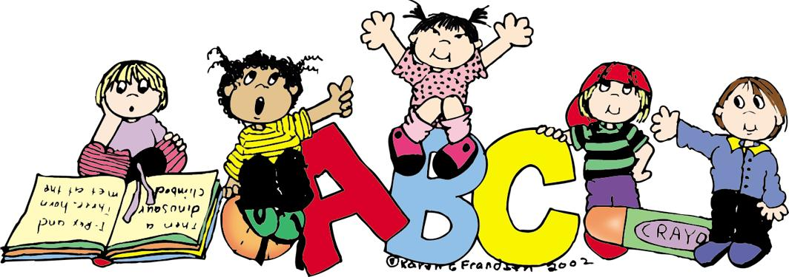

Integrated Preschool

Integrated Preschool Program Mission Statement
The mission of the Demarest Schools is to meet the needs of all students and to prepare them for a rapidly changing world. Through collaboration, we provide a caring environment that fosters academic excellence, cultural appreciation, ethical behavior and democratic values.
We support individuality and learner diversity that enables every student to realize his or her full potential. We seek to build collaborative partnerships among our students, staff, parent/guardian and community that foster growth and student achievement.
Demarest Schools aspire to create an environment that cultivates a lifelong love of learning and an exposure to new and creative ideas. This philosophy, combined with our proud traditions, will shape a positive future.

Program
3 year olds: Monday through Friday, 8:45 am to 2:30 pm
4 year olds: Monday through Friday, 8:45 am to 2:30 pm
“First Come, First Serve” basis
Yearly tuition $9,000.00
Maximum class size is 15 students
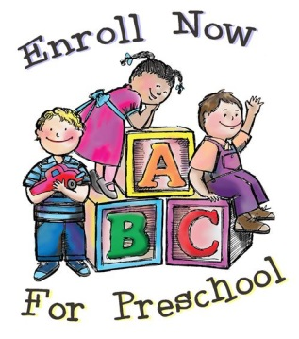
Eligibility
To be eligible for this program, your child must be 3 or 4 years old by October, 1, 2016 and toilet trained. A birth certificate, health records, proof of residency and completed registration forms are required for those applying. All forms are available on The Demarest website http://demarestsd.schoolwires.net .
Please contact Mrs. Kathy Daly, County Road School secretary, at 201-768-6060 Ext. 51535 to schedule your registration appointment.

Curiosity Corner Curriculum

The Curiosity Corner Curriculum aligns with the state and national early childhood standards. The curriculum is a New Jersey Department of Education suggested Early Childhood Curriculum.

What is Curiosity Corner?
Curiosity Corner is a complete, developmentally appropriate program for three and four year olds. The program encourages exploration through co-operative learning, center-based activities, reading circles, and themes to educate young children.
Curiosity Corner is designed to provide a strong foundation in language and literacy, mathematics, science, listening and social skills through thematic instruction.
Literacy: vocabulary and language, rhyming, phonological awareness, letters, words, print, and books.
Math: patterns and relationships, geometry and spatial awareness, number sense and counting, measurement, data collection, organization, and representation.
Science: matter and energy, living and nonliving things, life science, earth and the environment.
Curiosity Corner’s focus on language and literacy is based on research that supports the promotion of oral language and emergent literacy as key factors in later academic achievement.
A Typical Day
Gathering Circle…….Children are welcomed into the classroom and then become actively involved in meaningful activities.
Move It! …….A brief daily structured movement activity that is connected to learning and thematic concepts.
Clues & Questions……Is a whole-group activity that introduces the thematic concepts.
Rhyme Time…….Brings the whole-group activities to a close with active, theme-related rhymes and songs that promote phonological awareness.
Getting Along Together……Activities engage children in social problem-solving and self-regulation skill practice.
Plan & Play…….Students engage in imaginative play while exploring materials while experimenting, observing, and recording data. They interact together enhancing interpersonal, oral-language, and cognitive skills.
Story Telling and Retelling (STaR)……STaR engages the children in literature and concepts of print as they make predictions, recall events, and learn new vocabulary related to the theme.
Math Moments……Introduces numbers and number concepts using manipulatives and media.
Question/Reflection……During Question/Reflection the children recall and summarize activities to reinforce the skills and concepts they have learned throughout the day and the week.
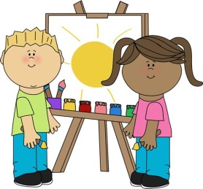

Goals

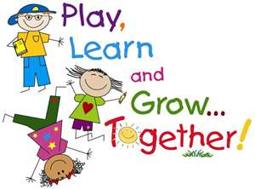

- To provide an opportunity for creative self-expression through play, music and art.
- To develop social skills of sharing, helping, and interacting with others.
- To develop a nurturing environment where achievement and continued effort are acknowledged and valued.
- To develop student communication skills to meet the demands of our global society.
- To prepare children for kindergarten, including teaching independence and self-help skills along with full visual alphabet recognition.
- To create a school community that provides a comfortable atmosphere to encourage a sense of pride and unity.
- To promote good citizenship through ongoing involvement in local and global issues.
- To foster the development of essential skills and attitudes for a productive life in a competitive world.
- To develop life-long habits that promote mental, emotional and physical well-being.

Health Services
There will be a full-time nurse in the district at all times who will work with the preschool children and their families by providing the following services.
- monitor and follow up on individual health records
- document and communicate with staff and parents about allergies and other health issues
- assist in written policies related to health, safety and nutrition
- assist parents in locating appropriate medical health resources as needed
- assist in the development of written emergency plans and procedures
- provide health-related training for staff and/or children and their families
The Demarest School District will conduct health related activities at school that provide information regarding health and hygiene.
In addition, students will be able to share information regarding proper health and hygiene with their family through a communication book.
